**Comprehensive Product Measurements for Enhanced 3D Room Planning**

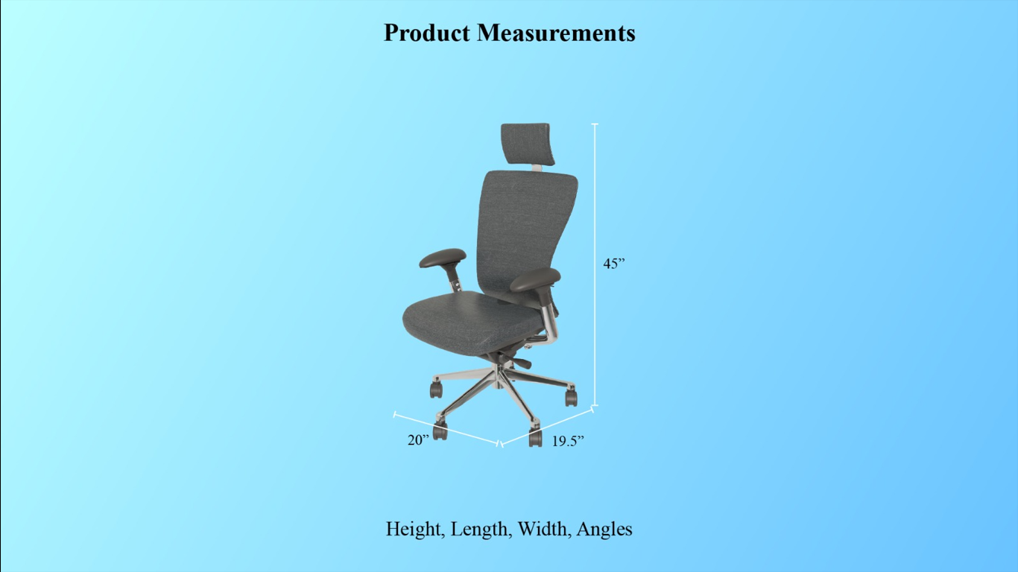

Dear [Recipient's Name],

I hope this email finds you well. I am writing to provide you with detailed product measurements that will greatly contribute to the accuracy and precision of our 3D room planner tool, tailored for both 3D home and 3D store environments. These measurements are aimed at enhancing the user experience by enabling seamless visualization and layout planning.

**Product Measurements:**

* **Height:** This refers to the vertical measurement of the product from its base to the highest point. Accurate height measurements are essential to ensure that products are properly scaled within the 3D environment. Users will be able to ascertain how tall each item is and how it fits within their space.
* **Length:** The length measurement represents the longest dimension of the product, typically measured from one end to the other. This measurement aids in placing products accurately within the room or store layout, enabling users to understand how much space each item occupies along a given axis.
* **Width:** The width measurement is the dimension that spans the product's side-to-side extent. This measurement is crucial for establishing the footprint of the product within the space. Users can determine how much area the product covers horizontally.
* **Angles:** Angle measurements are used to define the orientation of a product within the 3D environment. This includes the inclination, tilt, or rotation of the product. Accurate angle measurements allow users to precisely position items as per their desired placement and alignment.

By incorporating these comprehensive product measurements into our 3D room planner tool, we aim to offer our users a more immersive and practical experience when visualizing their ideal living or commercial spaces. Whether they're arranging furniture in a home or optimizing product displays in a store, these measurements will be instrumental in achieving accuracy and realism.

Please feel free to incorporate these measurements into our existing framework, and let me know if there are any specific technical requirements or considerations we need to take into account during the implementation process. I am confident that this enhancement will further solidify our position as a leading provider of 3D visualization solutions.

Thank you for your time and dedication to this project. I look forward to your feedback and progress updates.

Best regards,